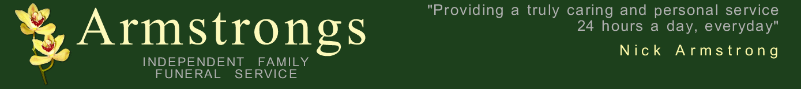
www.funeralhelp.co.uk
Whilst this is by no means an essential list as we will happily guide a family through all of the necessary arrangements without it, having this list can give you an idea as to some of the questions we will ask when making the arrangements for a funeral.

It can be nice to consult other members of the family about the various choices and decisions which will need to be made, especially if they cannot be with you when you make an appointment to come to see us.

A lot of the time when making arrangements a member of the family will say “I hadn’t thought of that” so hopefully this small list will help. Some of the questions we need to ask will be obvious and some not so but we have tried to put everything down. We suggest you also look at our personalising funerals page for some more ideas.

THINGS WE NEED TO KNOW

Name of deceased?

Age and date of birth?

Address of deceased?

Married/Widow/Widower/Separated/Single.

Where the person passed away?

Date and time the person passed away?

The Doctor of the deceased?

Is the coroner involved?

Will the service be burial or cremation?
*See end.

Will the service be in a church first or direct to the
crematorium/cemetery chapel.

On the day of the service would we go direct to the place
of the service leave from a family address?

Would you need any limousines?

What is the religion of the deceased?

Will the service be religious/non religious?

Were there any favourite hymns/songs?

Did the deceased wear any jewellery?
If so, will it stay on or be removed?

Had you thought about a press notice?
Which paper(s)?
See our helpful downloads page for templates

Had you thought about donations in lieu of flowers?
If so, which charity?
Would you have flowers from the family?
What would you like done with them after the service?

*If cremation.
Were there any thoughts on what to do with the cremated
remains afterwards?

*If burial.
Would this be in a new grave or an existing grave?
If new would it be a double or a single grave?

Is there a headstone?

The above is simply a list of some of the basic questions which will need to be answered when making arrangements. There are lots of ways to personalise the service to make it special and unique to the person and we are happy to discuss these with you when we meet. As already mentioned, please see our personalising funerals page for some more ideas.
As always, please feel free to call us on 01284 723889 with any questions you may have or
for advice on any aspect of our service.

